Department of Clinical and Molecular Medicine

Examination paper for
MOL3100 - Introduction to Molecular Medicine with project
MOL3000 - Introduction to Molecular Medicine

Examination date: 11.12.24

Examination time (from-to): 15.00-19.00

Permitted examination support material: D (No printed or hand-written support material is allowed. A specific basic calculator is allowed.)

Academic contact during examination: Bodil Kavli, Phone: 97661442

Academic contact present at the exam location: NO

OTHER INFORMATION
Get an overview of the question set before you start answering the questions.
This exam has two parts. Part 1 (52 marks), essay questions (Questions 1-8), write your answers in the textbox. Part 2 (48 marks), multiple choice questions (MCQ 1-24), select the best alternative (2 marks for correct answer, 0 for wrong answer).

Read the questions carefully and make your own assumptions. If a question is unclear/vague, make your own assumptions and specify them in your answer. The academic person is only contacted in case of errors or insufficiencies in the question set. Address an invigilator if you suspect errors or insufficiencies. Write down the question in advance.

No hand drawings: This exam does not include hand drawings. If you receive hand drawing sheets, this is by mistake. You will not be able to submit the sheets, and they will not be graded.

Weighting: Maximum score is 100 marks. Weighting is indicated on each question.

Notifications: If there is a need to send a message to the candidates during the exam (e.g., if there is an error in the question set), this will be done by sending a notification in Inspera. A dialogue box will appear. You can re-read the notification by clicking the bell icon in the top right-hand corner of the screen.

Withdrawing from the exam: If you become ill or wish to submit a blank test/withdraw from the exam for another reason, go to the menu in the top right-hand corner and click “Submit blank”. This cannot be undone, even if the test is still open.

Access to your answers: After the exam, you can find your answers in the archive in Inspera.

Essay Q1 (6 marks)

A typical human genome differs from the reference sequence (human genome project 2003) at 4-5 million single nucleotides (single nucleotide variants, SNVs).
- How can you predict whether a specific SNV is a likely functional variant (affecting the phenotype)?

- Protein-coding genes usually contain both coding exons (translated to protein) and exons that are not translated (not part of the reading frame). How can SNVs in untranslated exons affect the phenotype? Suggest two mechanisms.

- Explain why a single nucleotide mutation in an intron can be pathogenic. Indicate these most critical intron positions.

Answer:
- Likely functional variants

- SNVs that are within coding exons and give amino acid change
- SNVs within regulatory regions (e.g TF binding sites)
- SNVs in splice sites
- SNVs in miRNA and other non-coding RNAs

- SNVs in untranslated exons may affect the phenotype
- SNVs I untranslated exons (e.g. seed site for miRNA in 3’ UTR)
- mRNA stability
- export of mRNA out of the nucleus to the ribosome

- if splice sites are affected

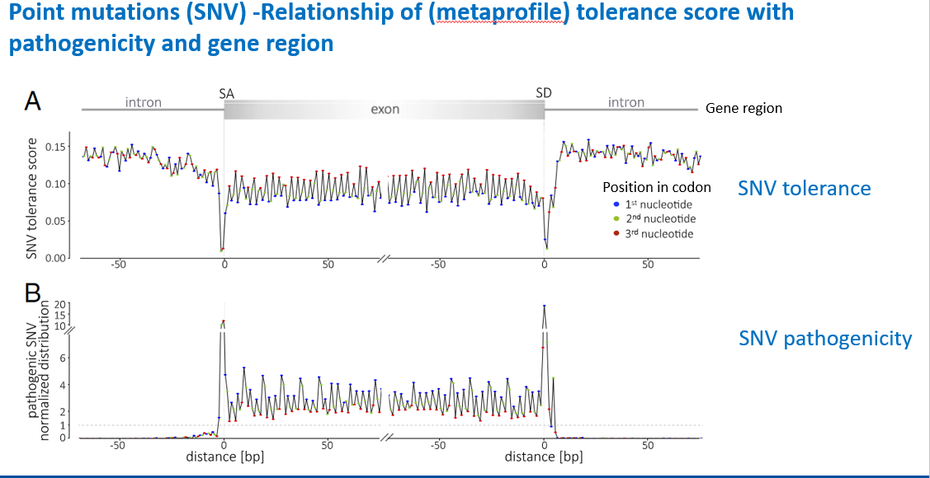
Essay Q2 (4 marks)

In addition to SNVs, genomic variation also involves longer sequence segments (structural variants).
- What types of structural variations are commonly observed in the human genome? (mention four)

- What kind of structural variation is used to generate DNA profiles from biological material? Why are these regions specifically suited for identification?

Answer
A)
- Deletions (large)
- Insertions (large)
- Copy number variation
- Variable number of tandem repeats (VNTR)

B)
- VNTRs (Variable Number of Tandem Repeats) produce many alleles
- Unrelated individuals are unlikely to share the same combination of alleles (two chromosomes)
- Detection of VNTR polymorphism was the first methods of ”DNA fingerprinting” to be used for identity testing
- The FBI uses 20 specific micro- and minisatellite locations (loci) for identification purposes. By determining the number of nucleotide repeats at each of the 20 loci, a unique profile is generated.
- The odds of two people having a profile match by chance is less than 1 in 1,000,000,000.

Essay Q3 (8 marks)

Monogenic diseases are caused by mutations in single genes and demonstrate different types of inheritance pattern.
Huntington’s disease (HD) is a progressive neurodegenerative monogenic disease with complete penetrance.
- Name and explain briefly the inheritance pattern of HD (2 mark)

- What is the genetic basis for the disease and the consequences of the HD mutation at the protein level? (3 marks)

- HD is a disease that display genetic anticipation. Define genetic anticipation and explain briefly the mechanistic background for genetic anticipation in HD? (3 marks)

Answer

- Autosomal dominant, both sexes are affected at similar incidence rates
  - dominant inheritance:
  - -Inheritance of one mutated allele is sufficient to develop the disease
  - -If one parent is heterozygous, there is a 50% risk of a child (both boys and girls) to inherit the disease

- Caused by mutation (CAG repeat expansion) in exon 1 of the HD gene on chromosome 4. CAG encodes the amino acid glutamine – thus an expansion of the CAG repeat region in exon 1 will result in a poly-glutamine (PolyQ) tract. Glutamine is at physiological conditions polar, and such polyglutamine tracts may be subject to increased protein aggregation, which is often seen in neurons of HD patients. It is however not clear whether these aggregates directly cause neuronal death.)

- Genetic anticipation is the earlier onset and more severe phenotype as the mutant gene is passed on. In HD this is because the CAG repeats have expanded from the previous generation. Studies have shown an inverse correlation between the number of CAG triplet repeats and age at onset

Essay Q4 (6 marks)

In a family the mother has been shown be heterozygous for a premutation in the Huntington’s disease (HD) gene.
- What is meant by a premutation in this case? Explain at the HD gene level.
- How would you consider the risk for her children to inherit a HD allele that will give rise to the disease? Argument for your answer.

- Would the risk for the children be similar if the father is the carrier of the premutation? Argument for your answer.

Answer:
- Between 27 and 39 repeats are considered premutations, which will lead to HD in future generations, if they expand. People with premutations have some elevated risk.

- The risk for inheriting the HD allele will be 50% for each child. Maternally transmitted alleles are usually of similar length. So, the overall risk for her children to inherit a HD allele that will give rise to HD can be considered low (50% compared to mother).

- As expansion is greater in spermatogenesis than oogenesis, a permutation is more likely to become a full mutation in the offspring if transmitted from the father. (50 % risk to inherit mutated allele but the allele may have more repeat extensions, which give a higher risk of developing HD)

Essay Q5 (6 marks)

The World Health Organization (WHO) has stated that antimicrobial resistance (AMR) is one of the top global public health threats in the 21st century.

- What are the main drivers behind the increase in AMR in bacteria in many countries? Mention at least four different drivers and indicate which two that are the most important.

- Two AMR bacterial species cause most AMR related deaths in Europe. Which two?

- How can we combat AMR development? List four important actions.

Sensor guide:
- Human antimicrobial misuse and overuse, veterinary/animal misuse and overuse, healthcare transmission, travel, lack of diagnostics, suboptimal vaccination, environmental contamination, suboptimal dosing and falsified/substandard drugs on the market. (Most important drivers in bold) (must mention at least four drivers and the two most important for full credit)

- E. coli resistant to third gen. cephalosporins (=ESBL EC) and MRSA (S. aureus resistant to standard treatment) (must mention both for full credit)

- Improve awareness and understanding of AMR, Strengthen knowledge and evidence through surveillance and research, Reduce incidence of infection through effective sanitation, hygiene and infection control measures, Optimize the use of antimicrobial medicines in human and animal health, New medicines, Better and faster diagnostic tools, vaccines and other interventions (must mention at least four of these for full credit)

Essay Q6 (10 marks)
Development of new strategies and drugs to treat cancer is a major goal within molecular medicine.
A) Give examples of four classes of inhibitors used in cancer treatment. Indicate how they work (target molecules/pathways/hallmarks) and why they usually are more toxic to cancer cells than normal cells. (8 marks)

B) What are the main limitations with such targeted cancer therapy? (2 marks)

Answers:
- Inhibits kinases/signal pathways:
- kinase inhibitors

Alters gene expression/epigenetics:
- Histone de-acetylase inhibitors: increase expression, opens DNA
- BET-inhibitors: binds to bromodomains recognized by molecules involved in chromatin modulation e.g. bind to acetylated lysine
- Methyltransferase inhibitors: inhibits DNA methyltranferases, e.g. DNMT1

Reduce DNA repair and cellular stress responses mm:
- PARP-inhibitors: reduce marking of ssDNA breaks, lead to dsDNA breaks
- PCNA inhibitors- impair PCNA scaffold functions, e.g APIM-peptide impair cellular stress responses, signaling (+ Y211F), TLS, metabolism

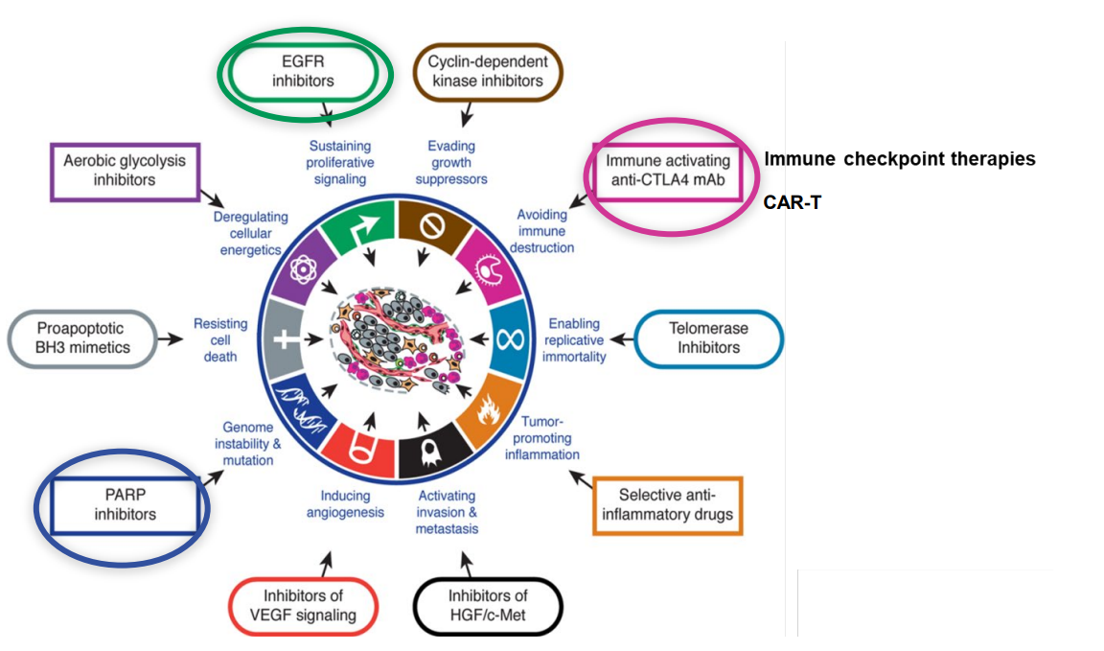

- Development of resistance

Essay Q7 (6 marks)
Cancer immune therapy is treatment where the immune system is helped to recognize and eliminate cancer cells.

Give three examples of different cancer immune therapies and explain briefly how they work.

- Monoclonal antibodies – against antigen more expressed in/on cancer cells
- BCG- installation in NON-Muscular Invasive Bladder Cancer. General increase in inflammations
- Cytokines – stimulate the immune system
- Bispecific T-cell engager – connect T-cells to cancer cells to enable rapid direct killing
- Antibody drug conjugate- Toxins linked to monoclonal antibodies recognizing cancer cells, cancer cell killed when antibody in endocytosed
- Immune checkpoint inhibitors – blocking the “breaks”

Essay Q8 (6 marks)
The cardiovascular system consists of the heart and blood vessels.

- There are two circulatory loops in the human body. Please describe their location and function.

- The vasculature is composed of arteries, veins and capillaries. Indicate the main differences between arteries and capillaries.

- Smooth muscle cells are present in the vascular wall. Describe in which part of the wall they are located and what function they have.

Answer:

- Two circulatory loops 1. pulmonary circulation, carries de-oxygenated blood to the lungs and back to the heart. 2. systemic circulation, carries highly oxygenated blood from the heart to the tissue and back to the heart

- Difference in size and composition of the wall layers between arteries and capillaries to fulfill their function and deal with blood pressure. Capillaries are only formed of a monolayer of endothelial cells. Arteries contain smooth muscle cells. Capillaries are thin to allow exchange of O₂ and nutrients to the tissue

- They are in the tunica media and are important for arterial contraction (vasoconstriction and vasodilatation) to redistribute blood to the body

MCQs
1.
Genetic disorders are caused by mutations.
What type of gene mutation is most common in human disease?
A | Single nucleotide missense mutations
B | Frameshift mutations
C | Trinucleotide repeat expansions
D | Loss or gain of codons

2.
The combination of single nucleotide variations (SNVs) in your genome can tell where you come from.
Which statement about SNVs is correct?
A | The majority of total identified SNVs is common in the population
B | The majority of total identified SNVs is rare in the population
C | The majority of SNVs in your genome is rare variants in the population
D | The majority of SNVs in your genome has allele frequency below 1%

3.
Typical symptoms of diabetes include always thirsty, frequent urination, always hungry and sudden weight loss.
Which is the main reason for frequent urination?
A | Drinking too much
B | Diabetes complication in kidney
C | Diabetes complication in brain
D | High glucose level in urine

4.
Diagnostic criteria for diabetes usually include fasting plasma levels of glucose, two hours after glucose load and HbA1c in %.
What is the molecular mechanism underlying HbA1c?
A | Hyperglycemia in red and white blood cells
B | Molecular binding of glucose to hemoglobin
C | Glucose toxicity in red blood cells
D | Diabetes complication in red blood cells

5.
In bioinformatics, PAM (Percent Accepted Mutations) and BLOSUM (BLOcks SUbstitution Matrix) are substitution matrixes used for sequence alignment of proteins.
PAM and BLOSUM are generated using which of the following data?
A | General chemical properties of the amino acids
B | A weighted scoring algorithm taking amino acid charge, frequency and size into account
C | Observed substitution frequencies from alignment of highly similar sequences
D | Statistical frequencies of amino acids appearing in sequences from a specific specie

6.
The Basic Local Alignment Search Tool (BLAST) finds regions of local similarity between sequences.
Which of the following statements is true when interpreting the output from a sequence alignment in BLAST?
A | A ‘+’ sign indicates identical amino acids
B | A lower Expect value indicate that the alignment is less likely to have occurred by chance
C | The Score value is estimated from the number of sequences in the BLAST multiple alignment
D | Sequence gaps are not shown, but must be inserted manually in the query sequence

7.
In a population of 2,000 individuals, the frequency of the LDL receptor gene (LDLR) wild type allele was found to be 99%.
How many individuals will have an LDLR mutation?
A | ~80
B | ~40
C | ~20
D | ~10

8.
An autosomal recessive disorder displays 45% penetrance.
What does this mean?
A | 45% of individuals heterozygous for the mutation will not express the disease
B | The mutation is seen in only 45% of individuals with the disease
C | 55% of individuals homozygous for the mutation will not express the disease
D | The mutation is seen in only 55% of individuals with the disease

9.
Various methods are used to diagnose infections.
What is meant by the term specificity of a diagnostic method?
A | The proportion of all false positive cases detected by the method
B | The proportion of all false negative cases detected by the method
C | The proportion of all true positive cases that is diagnosed by the method
D | The proportion of all true negative cases that is detected by the method

10.
The normal flora of the human body plays a crucial role in protecting against pathogenic microorganisms.
Which of the following is an indirect protective function of the normal flora?
A | Production of bacteriocins
B | Secretion of lactic acid
C | Physically covering the receptors for pathogens
D | Inducing secretion of IgS

11.
Pharmacokinetics (PK) and pharmacodynamics (PD) studies are vital for assessing the treatment effect of antibiotics.
Which effects of antibiotics in the organism is the focus of pharmacokinetics (PK) studies?
A | Drug effect over time
B | Drug concentration over time
C | Bactericidal effect over time
D | Postantibiotic effects

12
The genes of the bacterial genome can be classified as chromosomal or extrachromosomal, or as part of the core, accessory or pangenome.
Which part of the bacterial genome is most often associated with virulence and AMR?
A | Core genome
B | Accessory genome
C | Pangenome
D | Chromosomal genes

13
GWAS is a commonly used method in genetic research.
What does GWAS stand for?
A | Gene-wide analysis system
B | Genome-wide association study
C | Genome-wide allele screening
D | Gene wildtype allele study

14
Twin studies are used to study the relative contribution of genes and environment to complex diseases
Which of the following statement is true about the concordance rate in disease?
A | A higher concordance rate in monozygotic twins than dizygotic twins indicates a strong genetic component
B | A high concordance rate indicates that environmental factors are the primary cause
C | The concordance rate measures the percentage of genes shared between twins
D | Similar concordance rates between monozygotic and dizygotic twins indicate that genetic factors are likely more influential

15
Familial hypercholesterolemia is the most common autosomal dominant disorder.
Which genes are mainly associated with the disease?
A | LDLR, APOB, HTT
B | LDLR, APOE, FMR1
C | LDLR, APOB, PCSK9
D | LDLR, APOE, PCSK9

16
Mitochondriopathies affect organ systems with a high energy supply.
Which of the following statement is true?
A | Mitochondriopathies are most frequently caused by mutations in mitochondrial DNA (mtDNA)
B | Mitochondriopathies always follow an X-linked pattern of inheritance
C | Mitochondriopathies always follow maternal inheritance
D | Mitochondriopathies are most frequently caused by mutations in nuclear DNA

17.
All cancer treatments known today give side effects.
What is the most common side effects of immune therapies?
A | Hair loss and diarrhea
B | Uncontrolled Immune reactions
C | Fatigue and low appetite
D | Liver dysfunctions

18.
Different cancers have different characteristics that is believed to contribute to the cancer development
Why is liver cancer often associated with viral infection?
A | Virus infections drive cell division
B | Virus infection leads to chronic inflammation
C | Virus infection reduce the normal liver function
D | Virus infection activates the JAK-STAT pathway

19.
Epigenetic modifications can be dynamically regulated by epigenetic writers and erasers.
Which of the enzymes below is an epigenetic eraser?
A | DNA methyl transferase
B | Kinase
C | Ten Eleven Translocase (TET)
D | Acetyl transferase

20
DNA damage and replication errors may result in mutations.
A mutation is defined as:
A | a change in the DNA sequence of a gene that causes disease
B | a change in the DNA sequence that causes disease
C | a change in the DNA sequence away from the normal
D | a change in the DNA sequence of a gene away from normal

21.
RNA can be characterized by their function.
Which of the following small non-coding RNAs has a role in silencing of transposons?
A | miRNAs
B | snoRNAs
C | snRNAs
D | piRNAs

22.
In the Norwegian population a SNV (C>T) at chromosome 3 has the allele frequencies: C: 0.6 and T: 0.4
How many (in % of the population) will be heterozygous (CT)?
A | ~16%
B | ~24%
C | ~36%
D | ~48%

23.
Endothelial cell dysfunction is a central part in the process of atherosclerosis.
Which factors contribute to impaired endothelial cell function?
A | increased level of nitric oxide and increased level of oxygen radicals
B | increased level of nitric oxide and decreased level of oxygen radicals
C | decreased levels of nitric oxide and increased level of oxygen radicals
D | decreased level of nitric oxide and decreased level of oxygen radicals

24.
The epitranscriptome include all relevant modifications to the transcriptome (RNA) that do not involve a change in the nucleotide sequence.
What is the most common base modification in mRNA?

A | pseudouridine
B | 5-hydroxymethylcytosine
C | 5-methylcytosine
D | 6-methyladenosine

